“RUN THE LINE”
TRAINING GUIDE

ChampionsEverywhere GLENDALOUGH Co. Wicklow

Introduction

Page | 1
This document provides instructions on how to train for the “Run the Line” 13k and 22k running events. It provides a generalized training programme as well as the practical advice necessary to tweak it into “your programme”

Who are the coaches behind this plan?

Jason Kehoe and René Borg designed this plan. Together they form Irish company ChampionsEverywhere. Both are passionate hill runners. Here is a brief background on them:

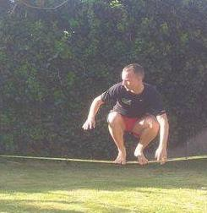Jason Kehoe

- Winner of King of the Mountains 2010 and 2011
- Irish development international (Snowdon 2010)
- Hell & Back Apollo winner 2013
- Carrauntoohil race winner
- Ireland’s only Lydiard Foundation certified coaches
- Ireland’s first MovNat Certified Trainer

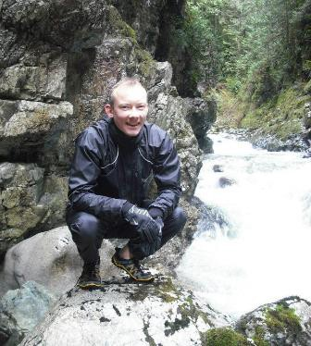René Borg

  - Ireland’s only UKA Fell and Mountain Running Level 2 coach
  - Ireland’s only Lydiard Foundation certified coaches
  - MovNat Certified Trainer
  - Mountain running coach for Crusaders AC in Dublin
  - Former secretary and webmaster of Irish Mountain Running Association

ChampionsEverywhere coach by the methods that have served our species well for thousands of years, rather than relying on recent fads which come and go. We the proven principles of old school coaches such as Arthur Lydiard, Arthur Newton, Georges Hebert and Percy Cerutty. We train our athletes through practical natural exercises (real-world) instead of muscle-focused modern exercises that took off with Arnold Schwarzenegger and Jane Fonda in the 80ies.

How to get started

From Sunday 22nd September you will have 10 weeks left to train for “Run the Line”. Ten weeks is
just about enough to get enough training done but you cannot make any major changes to

Page | 2
your routine. To undertake these programmes you need, as a minimum, to be able to run for 1 hour comfortably. Next:

- Set a dot in your calendar to start your first long run this Sunday 22nd September
- Next have a look at the training plan on the next page
- Second, have a look over the general instructions on how to use it
- Finally, look at our advice on other training and rest and recovery

How does your programme work?

Running is a skill that consists of three pillars:

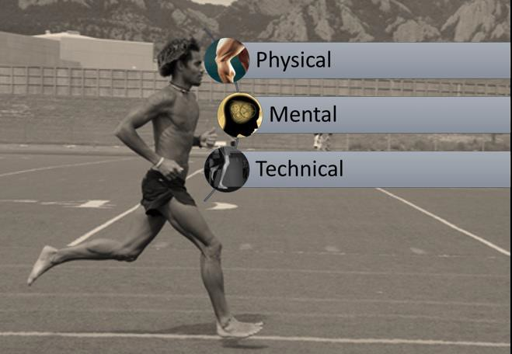

The only way to change your technical ability is to work with an experienced coach. Ten weeks is too little time to make major adjustments, so this programme will focus on the mental and technical aspect of training.

When you train your first focus should be:

  - movement “QUALITY” (how well you run)*
  - movement “QUANTITY” (how much you run)
  - movement “INTENSITY” (how hard you run)

Page | 3
* If you are injury free and feel fluid and light and recover quickly from workouts your movement quality is likely good. Do not add quantity or intensity unless this is the case – it never leads anywhere good. Contact us for advice on what to do to improve your movement quality to a point where you can run pain-free.

The ChampionsEverywhere training pyramid. Get things done in the right order!
Intensity

Quantity

Quality

If I miss the start date?

Take away one week per phase first. Any less than six weeks training will not be enough to benefit from a structured programme. It takes the body 6-weeks to replace old cells with new cells and gain most of the physiological benefits of training.

WEEK 1 TO 3 - GENERAL CONDITIONING (start Sunday 22nd September!)
Instructions: Start with the durations below and then increase each EFFORT run by 5-10 minutes per week. Step back if very fatigued for a week

Phase Date Priority Workout
I can run
1 hour
I can run
1.5 hours
I can run
2 hours Intensity Focus on: Details

Conditioning Sunday 1 Long run 1 hour 1.5 hours 2 hours 3-5

EFFORT Run over fores t track, hills or undulating road
Eas y enjoyable run. Focus on

Page | 4
Conditioning Monday 7 Recovery run 25 min 40 min 50 min 2-6 RECOVERY recovery

Conditioning Tues day 3 Medium long run 45 min 70 min 90 min 3-5 EFFORT
Even or m ixed terrain as you feel

Conditioning Wednes day 5 Recovery run 25 min 40 min 50 min 2-6 RECOVERY See below

Conditioning Thurs day 4 Strong fartlek 50 min 75 min 100 min 3-5 EFFORT
See below

Conditioning Friday 6
Strides
(15 minutes w arm up, 15 minutes cool dow n)
15 min 20 min 25 min 2-6 RECOVERY Track or even road s urface
See below. Fores t road/m ixed

Conditioning Saturday 2 Circuit Run 30 min 45 min 60 min 4-7 EFFORT
s urfaces .

WEEK 4 TO 6 - SPECIFIC CONDITIONING
Instructions: Keep a set course for your long run, medium long run and Out and Back. Increase pace slightly, not duration, each week

Phase Date Priority Workout
I can run
1 hour
I can run
1.5 hours
I can run Intensity Focus on:
2 hours
Details

Conditioning
Sunday
1 Long run
80 min
110 min
140 min
3-5
EFFORT
Keep a s et cours e. Undulating m ixed terrain
Eas y enjoyable run. Focus on

Conditioning
Monday
7 Easy trot
25 min
40 min
50 min
1-3
RECOVERY recovery

Conditioning
Tues day
3 Medium long run
60 min
90 min
110 min
3-5 EFFORT Even or m ixed terrain as you feel

Conditioning Wednes day
5 Easy trot
25 min
40 min
50 min 1-3 RECOVERY See ins tructions

Conditioning
Thurs day
4 Fartlek
70 min
70 min
70 min
4-7 EFFORT See ins tructions

Conditioning
Friday

Strides
6
(15 minutes w arm up, 15 minutes cool dow n)

15 min

20 min

25 min

2-6

RECOVERY Track or even road s urface

See below. Fores t road/m ixed

Conditioning
Saturday 2
Out & Back
50 min
65 min
80 min
4-7 EFFORT
s urfaces .

Week 7-9 - Race preparation
Instructions: Only do effort sessions if fully recovered. Prepare to skip 1 of 3 if needed. Look for weaknesses in your fitness in the time trials.

Phase Date Priority Workout I can run
1 hour
I can run
1.5 hours
I can run Intensity Focus on: Details
2 hours

Stamina Sunday 2 Long run 100 min 120 min
150 min 3-5 EFFORT Run on eas y cours e

Stamina Monday 4 Easy trot 30 min 35 min 40 min 1-3 RECOVERY On even terrain

Stamina Tues day
5 Intervals 20 min 30 min 40 min 6-9 EFFORT Trail or undulating roads

Stamina Wednes day 3 Medium long run 50 min 80 min 90 min 3-5 RECOVERY Flat and eas y terrain

Stamina Thurs day 6 Strong Fartlek 70 min 70 min 70 min 4-7 EFFORT
See below

Strides
Stamina Friday 7 15 min 20 min 25 min 2-6 RECOVERY Track or even road s urface
(15 minutes w arm up, 15 minutes cool dow n)

Stamina Saturday 1 Time trials (or Test races) 5k to 10 mile 4-7 EFFORT
Start with 10 m ile, then 10 km , then 5 km at 95% effort

RACE WEEK
Instructions: A difficult week. You must stay sharp yet fresh. Keep intensity in workouts but drop volume hugely. Eat well and go to bed by 22:30 every night!

Phase Date Priority Workout
I can run
1 hour
I can run
1.5 hours
I can run
2 hours Intensity Focus on: Details

Sharpening Sunday 2 Long recovery run 45 min 55 min 70 min 3-5 RECOVERY Run on eas y cours e

Sharpening Monday 4 Windsprints 10 min 10 min 10 min 6-7 EFFORT
On even terrain

Sharpening Tues day 5 Fartlek 20 min 30 min 40 min 3-5 RECOVERY Eas y terrain, no tough hills

Sharpening Wednes day 3 Race pace run 10 min
10 min 10 min 2-6
EFFORT Run on lightly undulating trails

Sharpening Thurs day 6 Recovery run 15 min
25 min 30 min
1-3
RECOVERY Flat and eas y terrain

Sharpening Friday 7
Recovery run
10 min
20 min
25 min 1-3 RECOVERY Flat and eas y terrain

THE RACE Saturday 1 RUN THE LINE
13km to 28km
6-9 EFFORT ENJOY YOUR RACE!

Sample training plan created by ChampionsEverywhere. All rights reserved. For personalised training plans go to our website www.championseverywhere.com

How to use the training plan

First things first

Page | 5

Check the following:

- How many days do I run per week now?
- How many minutes do I run for my long run and overall for the week?

For this programme you should not increase the days you run by more than 1. So if you run 4 days per week now choose the top-5 workouts (use the priority column for this information)

If you can run for 1 hour then you should use the approximate durations for the 1 hour column. If you fall in between two columns (i.e. “I can run 70 minutes”) use a duration in the middle.

Can I change the durations?

Yes. We are coaches, not prophets. Only you can know what the right volume is for you each day. Remember that you cannot gain any improvement in your comfort zone, but don’t jump on the “no pain, no gain” brigade – training should build you up, not tear you down. So start a bit out of your comfort zone without jumping way into the far end and feel free to improvise.

When we say that QUALITY comes first, it means you should never run so far or so hard that your running form breaks down completely. All this achieves is teaching you to run badly as well as trashing your body. Think long-term. You won’t just run this one race. You may want to run hundreds.

How do I understand and execute the workouts?

To use each workout you need to look it up in the ChampionsEverywhere training library and read it carefully before you do it the first time.

- Our workout library
- Ferocious fartleks (example of Fartlek sessions)

For interval training we suggest the following. You should run all recoveries (easily) or walk. This will teach you to recover on the run which is critical for an endurance event such as RTL.

Page | 6
I can run: | 1 hour | 1.5 hours | 2 hours
Week 1 | 3-5 x 800m HARD  (or 2.5 to 3 minutes) | 4-6 x 800m HARD  (or 2.5 to 3 minutes) | 5-7 x 800m HARD  (or 2.5 to 3 minutes)
Week 2 | 3-5 x 1000m HARD  (or 3.5 to 5 minutes) | 4-6 x 1000m HARD  (or 3.5 to 5 minutes) | 5-7 x 1000m HARD  (or 3.5 to 5 minutes)
Week 3 | 3-5 x 800m HARD  (or 2.5 to 3 minutes) | 4-6 x 800m HARD  (or 2.5 to 3 minutes) | 5-7 x 800m HARD  (or 2.5 to 3 minutes)

Never run intervals beyond “technical failure” – that means once your running form starts to fall to pieces completely, you have had enough. Stop while you still have one more left if you had to!

If you don’t understand the purpose of a workout email our team – we’re here to help!

What’s the structure of the plan

Each phase lasts 3 weeks and is part of a bigger 6 week cycle. Three weeks is the minimum you can focus on any type of training and expect to get results from it. After 6 weeks your body has made physical changes based on the demands you have imposed on it with your training.

 | Day | Purpose | How you should feel
 | Long run | To build endurance and duration | Pleasantly tired
 | Recovery run | To stay in good health. Recover. | Fresher
 | Medium long run | To build endurance and duration | Pleasantly tired
 | Recovery run | To stay in good health. Recover | Fresher
 | Fartlek | To build stamina and get used to high speed | Tested
 | Strides | Build pure speed | Faster!
 | Circuit Run | Race specific: maintain higher paces | Confident

Each week is like has its own peak with Saturday as “the big day” where you do your most race specific workout. So your goal every week needs to be to use all other workouts to prepare to run really well on Saturday. Try to run at the same time as the race starts and using as much of the same equipment as possible. That way you’ll be able to do 9 small race simulations before the big day!

If you are trashed by Saturday it means your training has been too hard and you are not recovering properly after each workout.

Can I get any coaching support?

Page | 7
There is a lot of support you can get from our team and our runners:

- Join our Facebook group “Old School Running” and just ask questions!
- Join our Old School Fartleks every Thursday to run with a group (free). See details in the
Facebook group above
- Purchase 1-to-1 training, group training or personalized training plans on our website
- Go on a “ Masters of Running” workshop to improve your technique (next date: 9th/10th November)

What other training should I do?

Until the days of Arnold Schwarzenegger and Jane Fonda, physical fitness and physical education was about training movements – not muscles. Since then an industry has spawned of weird and wonderful exercises.

Our advice is to go back and train movement instead. For a mountain run like “Run the Line” the best movements to practice are balancing, jumping, vaulting, crawling (!), walking and running.

To get the best of this we recommend you get personal coaching first to see where your current skill level is at. For inspiration look at the “MovNat of the Day” workouts here.

You can find all the exercises shown by MovNat founder Erwan le Corre on the MovNat YouTube channel. Use only the Beginners versions at first and stay within your own limits.

For more ideas:

  - Check out their “ MovNat of the Day”
  - Check out our “ Gate Protocol” using a Coillte gate!

If you would like to get personal instruction, consider our “ Hell & Back” training series that runs from Saturday 21st to November 2nd in various locations in Wicklow and Dublin, or contact us for personal training.

